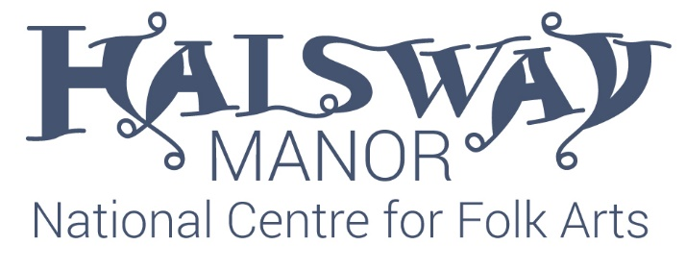

The Paul Sartin Bursaries are awarded in his memory to cover 50% of the cost of a weekend or week-long course at Halsway Manor for anyone aged 18 – 30 whose financial circumstances would otherwise prevent them from attending.  
  
Bursaries are limited and are awarded on a first-come, first-served basis to individuals who fulfil the criteria. Bursaries can be used for any in-house course which does not already have favourable pricing for young people.  
Applicants will be selected by the CEO, Crispian Cook, and the Programme Manager, Rachel Wilkinson.

If you would like to be considered for a bursary, please complete the form below and email it to [chiefexec@halswaymanor.org.uk](mailto:chiefexec@halswaymanor.org.uk)

We may contact you for an informal chat or more information, and you will hear from us whether or not we are able to offer you a bursary.

|  |  |
| --- | --- |
| Name |  |
| Address |  |
| Email address |  |
| Age |  |
| Please could you tell us a little about your circumstances and why you are applying for a bursary. (Max 300 words) | |
|  | |